HR 2 BREAKDOWN

# TEAM: [21Su01-CWC]

## Due Date: 11/5/2021

Provide several pics of the current state of your completed system thus far here:

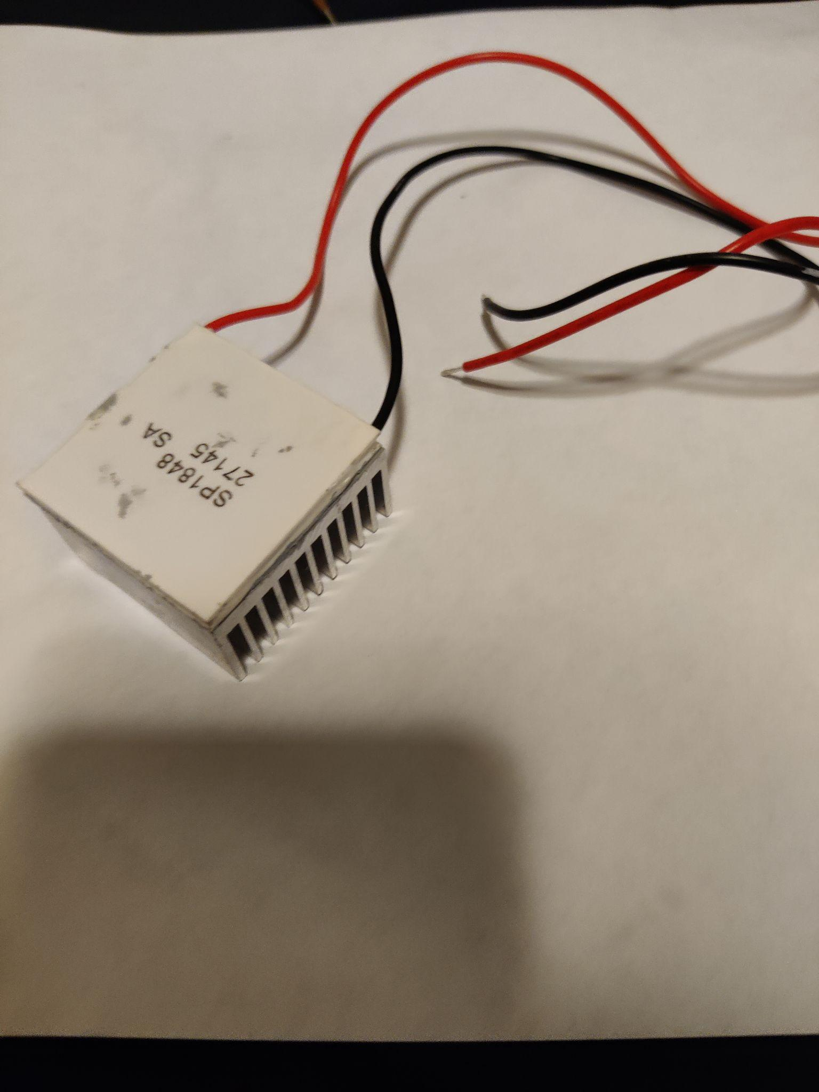

Fig.1

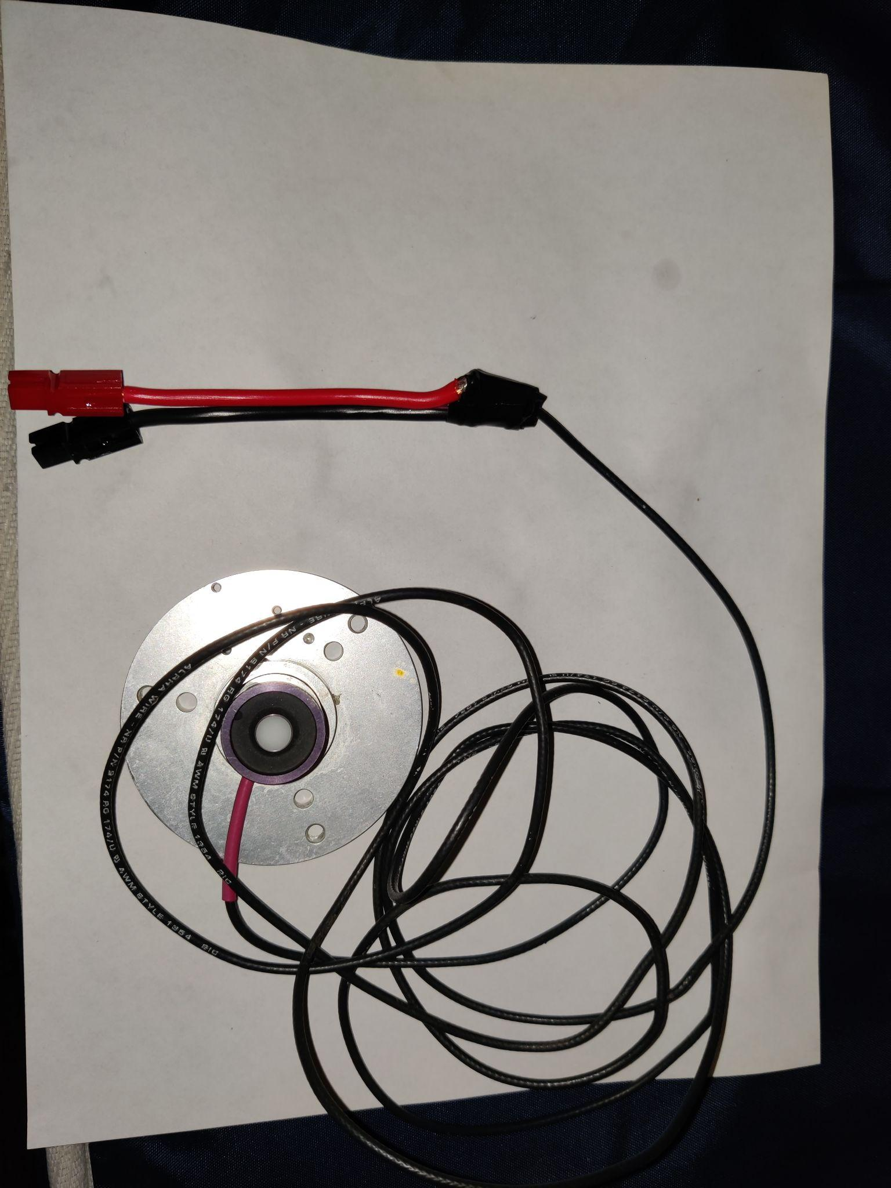

Fig.2

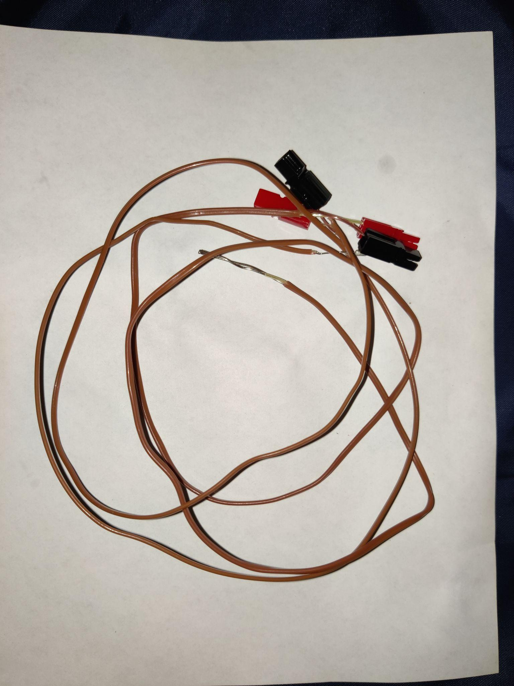

Fig.3

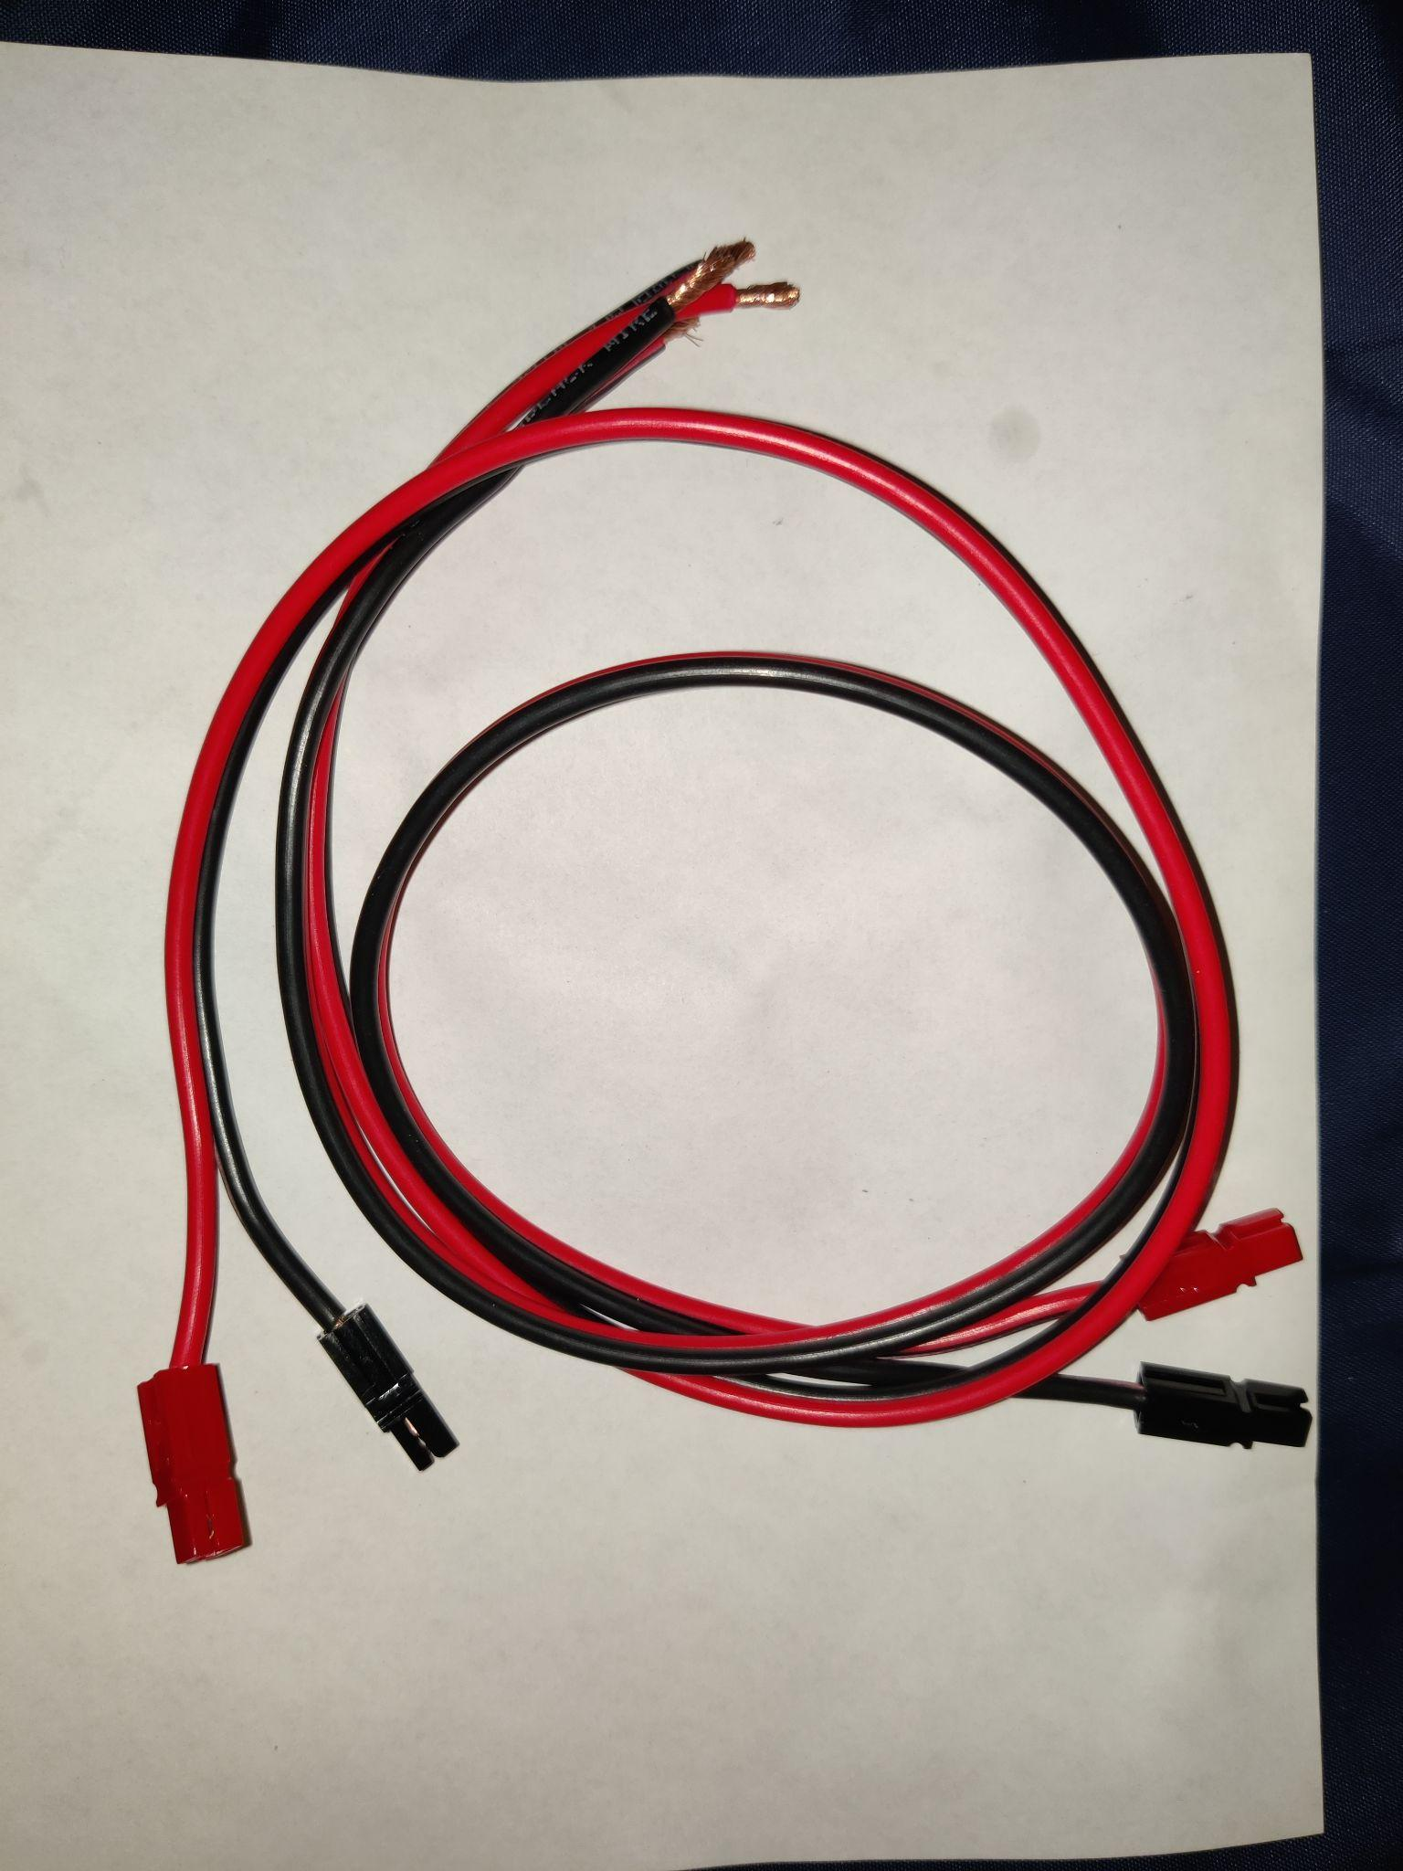

Fig.4

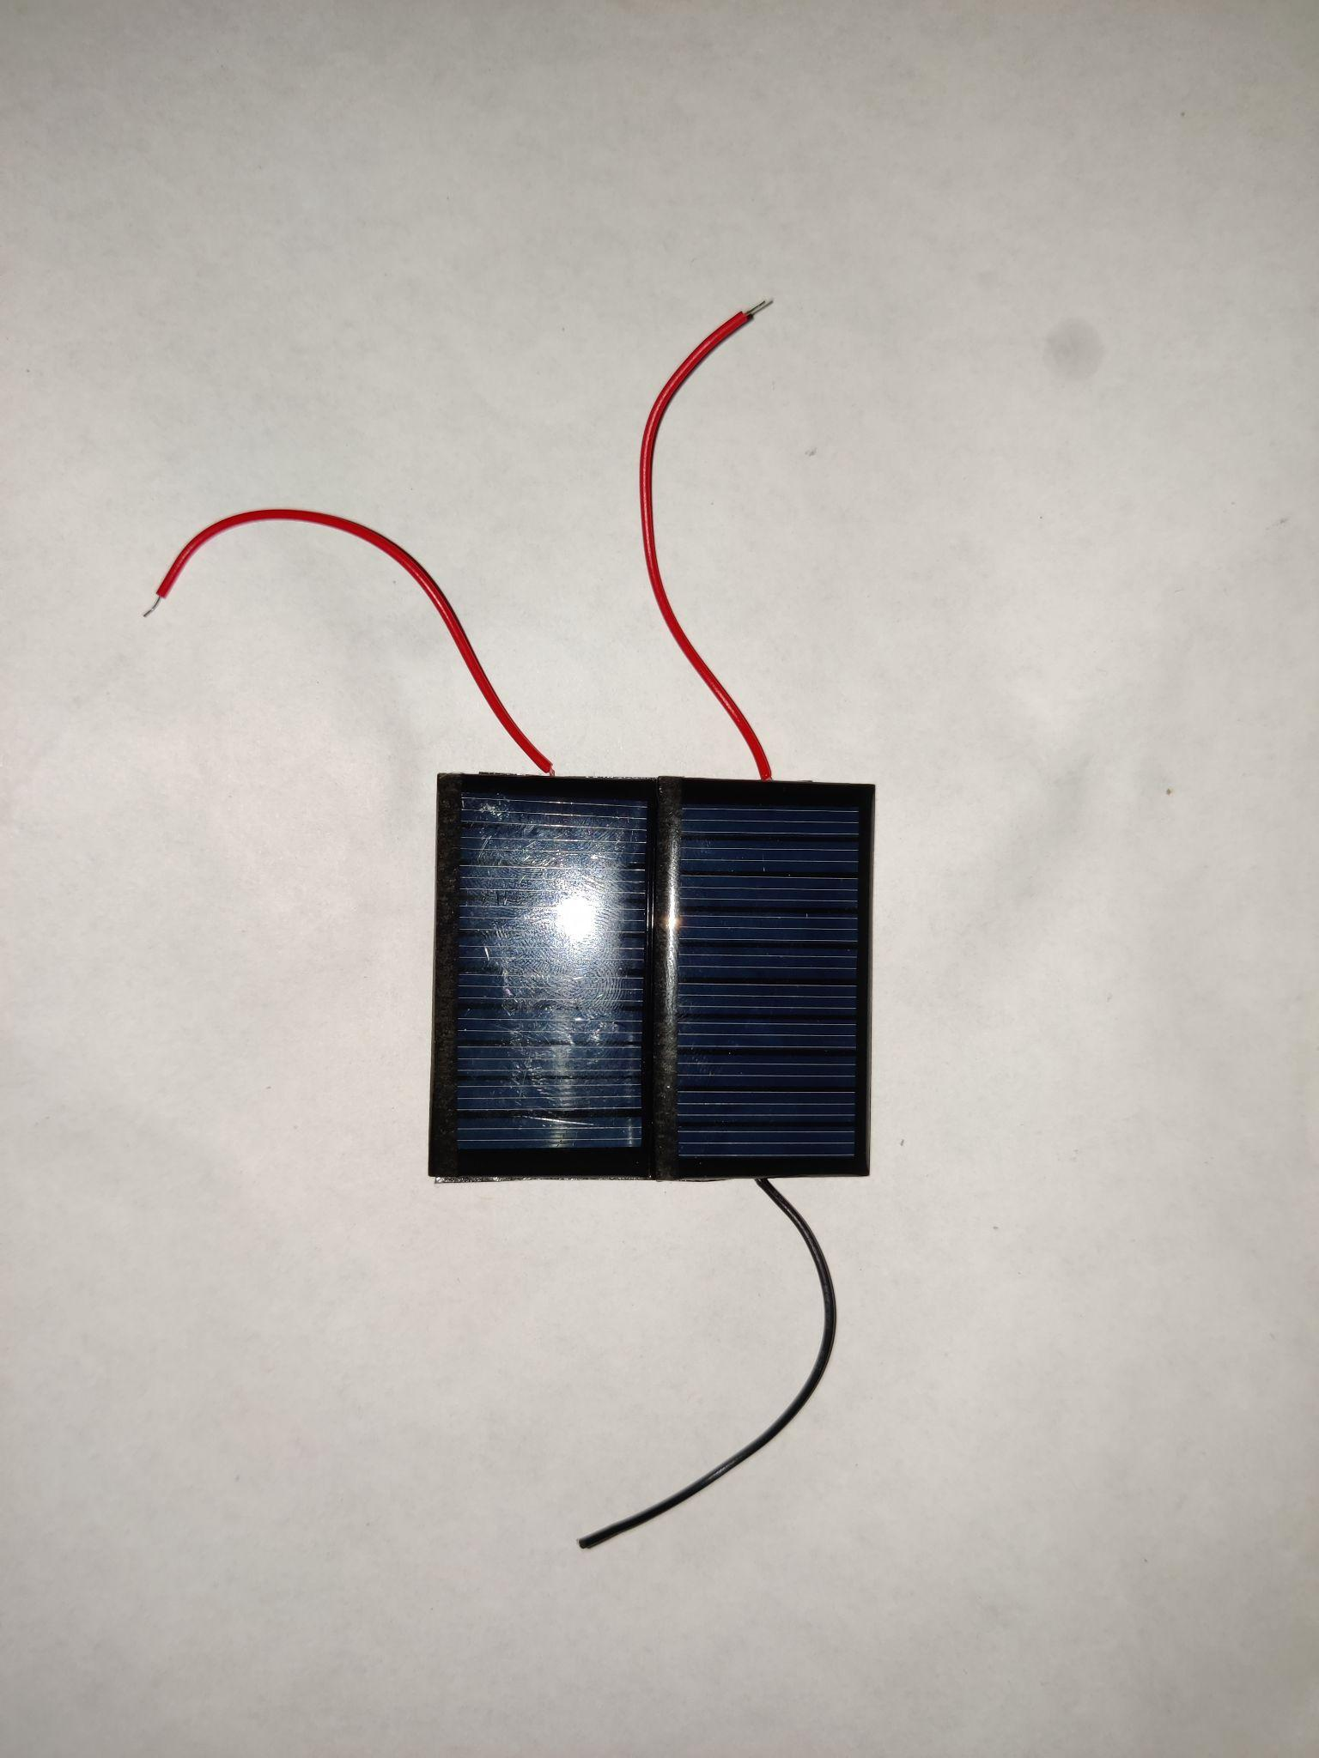

Fig.5

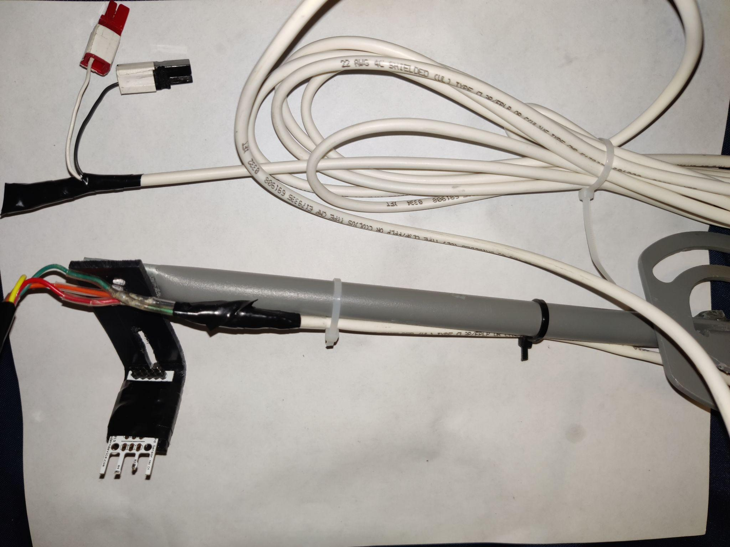

Fig. 6

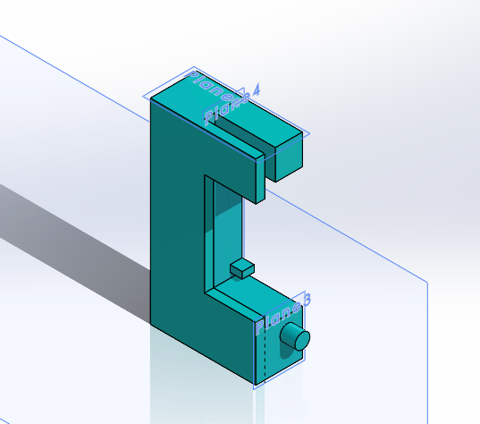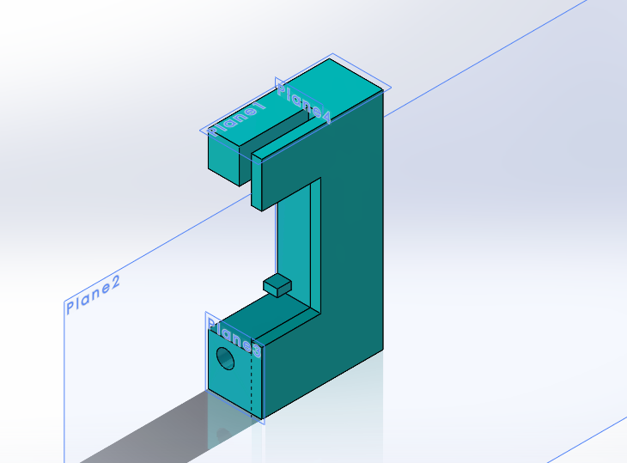

Fig. 7

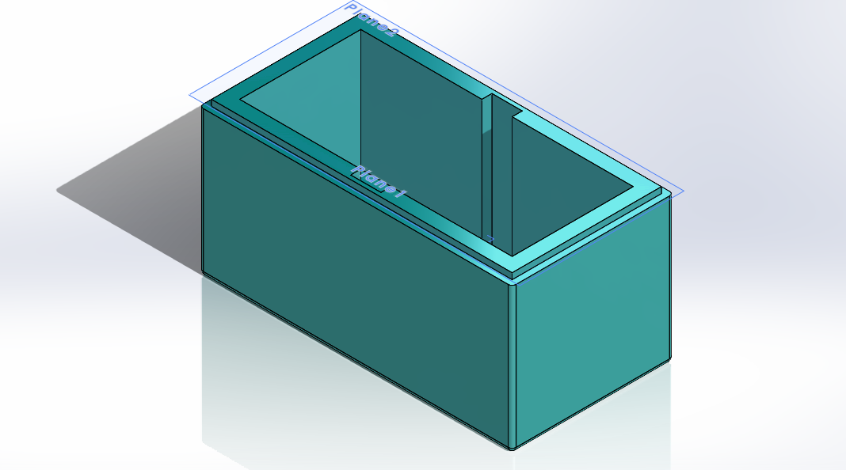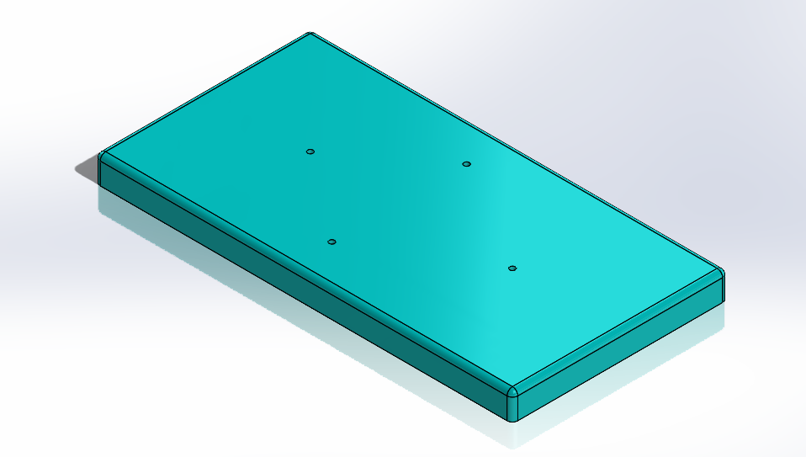

Fig. 8

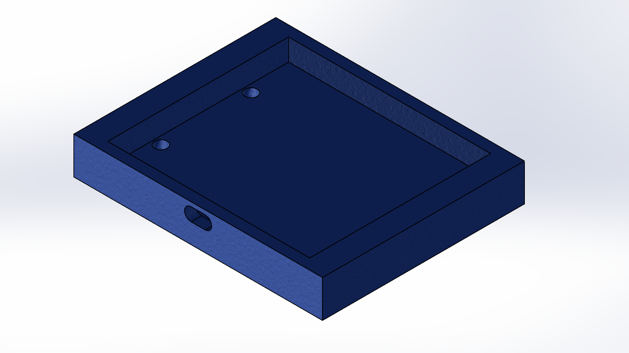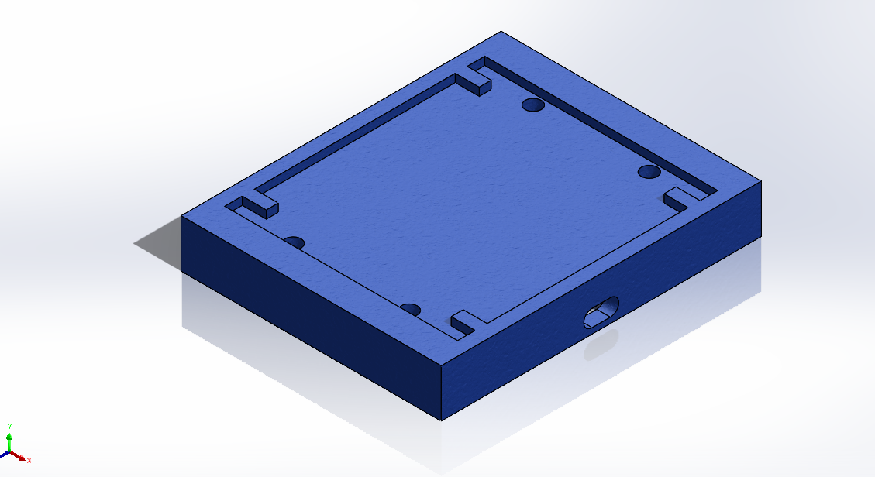

Fig. 9 solar panel sink

The following are the Action Items each person completed between Hardware Review 1 and Hardware Review 2:

**Team Member:** [Yuxuan Gu](mailto:yg297@nau.edu)

| Action Item | **Date Completed** | **Result/Proof of Completion** |
| --- | --- | --- |
| Fixing | 10/26/2021 | Pyranometer (Fig.2) |
| Soldering | 10/26/2021 | Fig. 1,3,4,5 |
| CAD | 11/2/2021 | Fig. 7&8 |

**Team Member: Yuanhua Zhao**

| Action Item | **Date Completed** | **Result/Proof of Completion** |
| --- | --- | --- |
| welding and fixing | 10/26/2021 | wind sensor/solar panels/thermocouple [Figure. 3, 5 and 6] |
| make CAD of 3D printing | 11/05/2021 | solar panels sink [Figure. ] |
| programing | 11/01/2021 | Labview Vi |

The following are the Action Items for each team member between HR 2 and the Final Product presentation:

| Team Member | **Action Items** | **Date Due** |
| --- | --- | --- |
| Yuxuan Gu | 1. Improve CAD for 3D printing 2. Soldering and building subsystems 3. Testing subsystems | 1. 11/7/2021 2. 11/14/2021 3. 11/21/2021 |
| Yuanhua Zhao | 1. 3D printing 2. welding solar panel 3. programing 4. testing | 1. 11/14/2021 2. 11/14/2021 3. 11/21/2021 4. 11/28/2021 |